Question 1: What happens if we change the number of components?
Change PCA(n_components=2) to PCA(n_components=3).
- How many features are present after reduction?
Ans- after changing 2 to 3 components then number of features will reduced to 11 to 3 features but the samples remains same (1143) and the features are called by (P1,P2,P3).
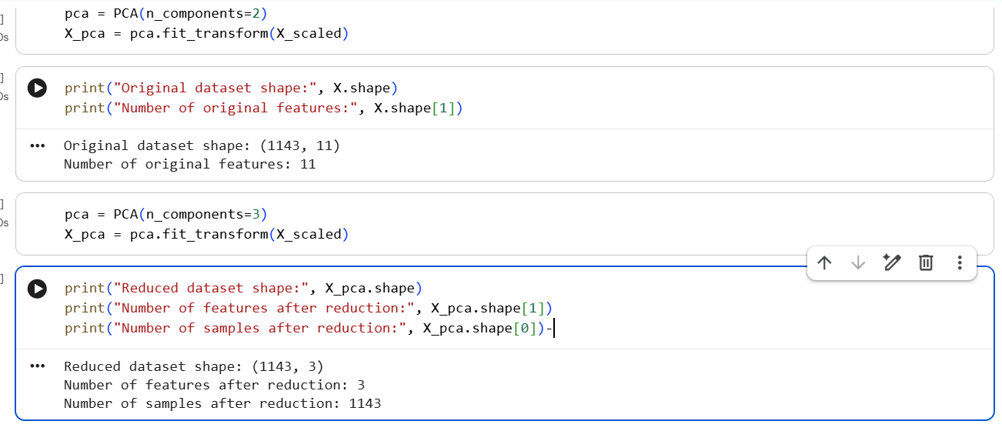
- Does the number of samples change?
Ans- no the number of samples are not changed it remains same (1143) here the sample means no of rows not no of features.
- Does the total variance retained increase or decrease?
Ans- The total variance retained will increases
- With 2 components: 45.77% variance retained.
- With 3 components: 60.07% variance retained.
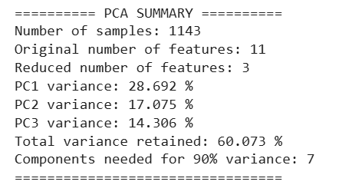

Question 2: What happens if standardization is removed?
Replace X_scaled with X in the PCA transformation.
- Does the explained variance ratio change?
Ans- Yes, the explained variance ratio changes significantly when standardization is removed.
- With standardization, the first two components retain 45.77% of the variance.
- Without standardization, the first two components retain 99.50% of the variance.
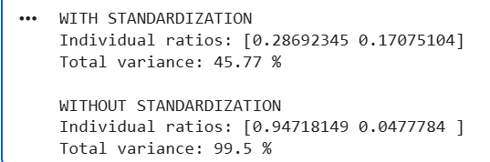
- Why might features with larger numerical scales influence PCA more strongly?
Ans- PCA identifies directions with maximum variance. Features with larger numerical scales can have much larger variances and therefore its dominate the principal components.
- Is standardization always necessary?
Ans- No. Standardization is generally recommended when features have different units or numerical scales. However, it may not be necessary when all features already have comparable scales

Question 3: What happens if we retain more components?
Try 1, 2, 3, 5 and 10 principal components.
1.How does the cumulative explained variance change?
Ans-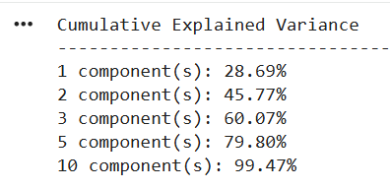
Cumulative explained variance increases as the number of principal components increases. In our WineQT dataset, 1 component retains approximately 28.69% of the variance, while 2 components retain 45.77%, 3 components retain 60.07%, 5 components retain 79.80%, and 10 components retain 99.47%.
This shows that adding more principal components preserves more information from the original dataset. However, using more components also reduces the benefit of dimensionality reduction.
2. How many components are needed to retain at least 90% of the variance?
Ans- 7 principal components. (90.92%)
3. Is reducing to two components always the best choice?
No. Two components are useful for visualizing data in two dimensions, but they may discard important information.
In dataset, two components retain only 45.77% of the variance. If we want to retain at least 90% of the variance, we need 7 components.

Question 4: What happens to the visualization?
Plot the first two principal components and observe the wine-quality groups.
1. Are the classes clearly separated?
Ans-When I plotted the first two principal components, I observed that the wine-quality groups were not clearly separated. Some points with different quality scores overlap in the graph. This is because PCA reduces the original features to two components, which may not contain enough information to distinguish all wine-quality groups.

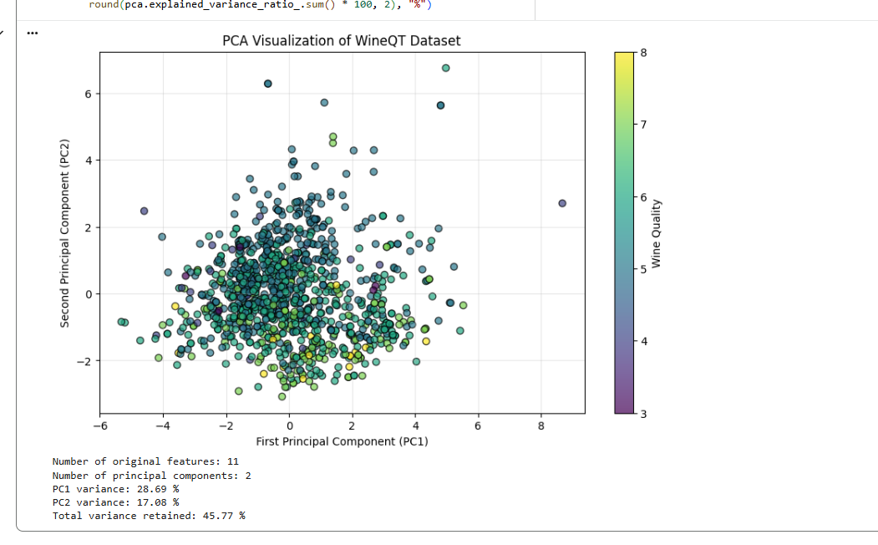
2. What information might be lost when reducing 13 features to 2?
Ans-When we reduce the number of features to two principal components, some information from the original dataset is lost. In my WineQT dataset, I reduced 11 wine measurement features to two principal components. These two components retain only the variance shown by the output of my program, while the remaining variance is not retained in this two-dimensional representation. As a result, some important patterns and differences between wine samples may be lost.
3. Does PCA use the class labels to create the components?
Ans-No, PCA does not use class labels to create the principal components. It is an unsupervised learning technique that uses the input features to find the directions of maximum variance. In my program, the wine-quality values are used only to display different colors in the graph. They do not affect the calculation of the principal components.

Question 5: Does PCA select existing features?

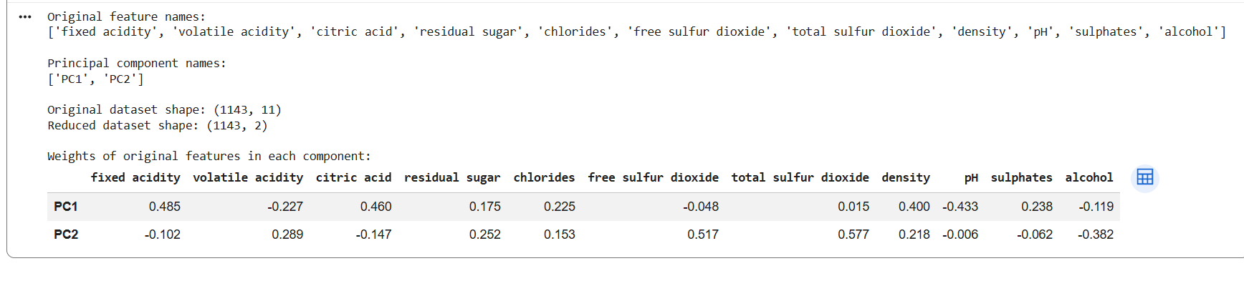

1. Are the two principal components original Wine dataset columns?
Ans-
No, the two principal components are not original columns of the WineQT dataset. They are new features created by combining the original wine measurement features using different weights. PC1 captures the maximum possible variance, and PC2 captures the next highest variance while being uncorrelated with PC1.
2. What is the difference between feature selection and feature extraction?
Ans-
Feature selection means choosing important features directly from the original dataset without changing them. Feature extraction means creating new features by transforming or combining the existing features.
For example, selecting alcohol and pH from the WineQT dataset is feature selection. Converting the 11 wine measurement features into two principal components using PCA is feature extraction.
3. Why is PCA considered a feature extraction technique?
Ans-
PCA is considered a feature extraction technique because it creates new features from the original features by combining them using mathematical weights. These new features are called principal components. PCA reduces the number of features while trying to preserve as much information as possible from the original dataset.

